**Photoshop Setup Specs:**

|  |  |  |
| --- | --- | --- |
| **iPhone 3.0** Screen resolution: *72 ppi* Screen size: *320 x 480 px* Icon size: *57 x 57 px* File format: *PNG-24* | **iPhone 4.0** Screen resolution: *72 ppi* Canvas size: *640 x 960 px* Icon size: *114 x 114 px* File format: *PNG-24* | **iPad** Screen resolution: *72 ppi* Canvas size: *768 x 1024 px* Icon size: *72 x 72 px* File format: *PNG-24* |

**Graphics for the iTunes Store**  
Icon: 512 x 512 px (.tif, .jpg or .png, 72dpi, RGB)  
iPhone Screenshots: 320 x 480 px or 640 x 860 px (.tif, .jpg or .png, 72dpi, RGB)  
iPad Screenshots: 1024 x 768 px (.tif, .jpg or .png, 72dpi, RGB)

315X143=Rounded Button

110X110=Graphic

134X85=Standard Gift Card

Places for supporting files…

<http://www.iconfinder.com>

<http://www.1001freefonts.com/>

http://www.glassybuttons.com/glassy.php

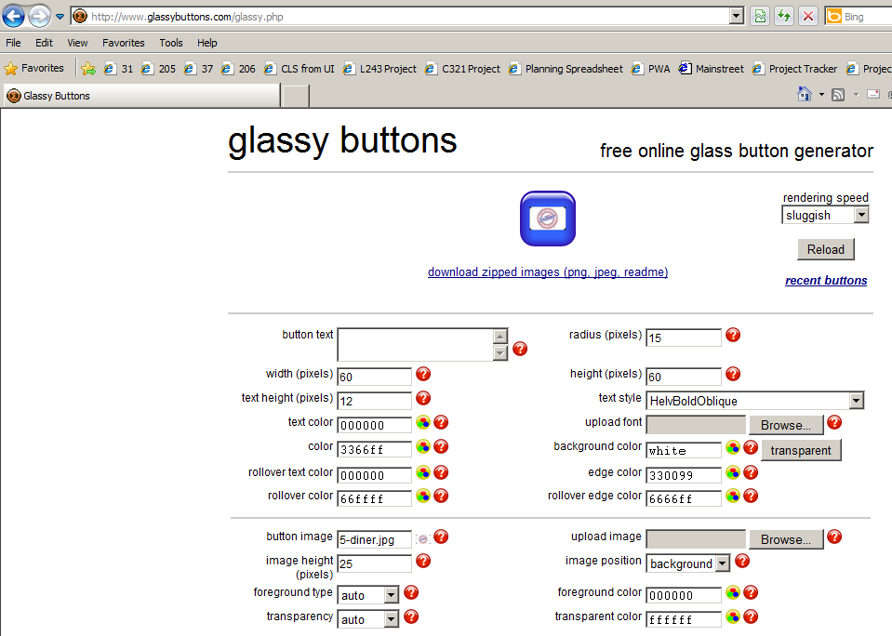

http://dabuttonfactory.com/